
American International University-Bangladesh (AIUB)
Department of Computer Science
Faculty of Science & Technology (FST)
PROJECT TITLE
A Software Engineering Project Submitted
By
Semester: Fall_24_25 |  | Section: | Group Number:
SN | Student Name | Student ID | Contribution (CO3+CO4+CO5) | Individual  Marks
1 | Md. Fardin Hossain Neloy | 22-48812-3 | 25%
2 | Ayman Ur Rahman | 22-49320-3 | 25%
3 | Nipa | 21-45816-3 | 25%
4 | Sanjukta Das | 22-47801-2 | 25%

The project will be evaluated for the following Course Outcomes

CO3: Select appropriate software engineering models, project management roles, and their associated skills for the complex software engineering project and evaluate the sustainability of developed software, taking into consideration the societal and environmental aspects | Total Marks
Appropriate Process Model Selection and Argumentation with Evidence | [5 Marks]
Evidence of Argumentation Regarding Process Model Selection | [5Marks]
Analysis of the impact of societal, health, safety, legal, and cultural issues | [5Marks]
Submission, Defense, Completeness, Spelling, grammar, and Organization of the Project report | [5Marks]
CO4: Develop a project management plan to manage software engineering projects following the principles of engineering management and economic decision process | Total Marks
Develop the project plan, its components of the proposed software products | [5Marks]
Identify all the activities/tasks related to project management and categorize them within the WBS structure. Perform detailed effort estimation correspond with the WBS and schedule the activities with resources | [5Marks]
Identify all the potential risks in your project and prioritize them to overcome these risk factors. | [5Marks]
CO5: Perform as an effective team member or leader in diverse team settings and solve multi-disciplinary problems in the computer science and engineering domain | Total Marks
Taking project responsibility: perform assigned tasks on time independently | [5 Marks]
Contribution to project group meetings, sharing fruitful ideas | [5Marks]
Positive attitude towards group work, collaboration, compromise, helping others to understand their project work responsibility | [5Marks]
Showing respect and value towards other team member's opinion | [5Marks]

Description of Student’s Contribution in the Project work

Student Name: Md. Fardin Hossain Neloy
Student ID: 22-48812-3
Contribution in Percentage (%):
Contribution in the Project:
- Contribution Description 1
- Contribution Description 2

___________________
Signature of the Student

Student Name: Ayman Ur Rahman
Student ID: 22-49320-3
Contribution in Percentage (%):
Contribution in the Project:
- Contribution Description 1
- Contribution Description 2

___________________
Signature of the Student

Student Name: Nipa
Student ID: 21-45816-3
Contribution in Percentage (%):
Contribution in the Project:
- Contribution Description 1
- Contribution Description 2

___________________
Signature of the Student

Student Name: Sanjukta Das
Student ID: 22-47801-2
Contribution in Percentage (%):
Contribution in the Project:
- Contribution Description 1
- Contribution Description 2

___________________
Signature of the Student

PROJECT PROPOSAL

Background to the Problem
In recent decades, emergency services like fire service, providing ambulance, law enforcement service etc. have become a necessity for everyday human life. Emergency services have evolved Page 4 of 56 © MMH quite a lot in the past years by pushing the boundaries and incorporating technological innovations. Emergency services are captivating due to their potential to save lives. The challenge lies in minimizing the response time, providing these services in the least amount of time from the time of requesting the service and managing these services simultaneously. The problem arises from the great amount of time emergency services are provided from the time of the request and people facing consequences because of that. Ease of use, automation and solid software like interface is essential to overcome these challenges and provide emergency services in the least amount of time. The problem is super important because it affects our ability to be safe and to have faith in cases of emergencies. Emergency services can teach us how important someone’s time can be in such cases. When we create an efficient and innovative system and deploy it to help people to have fire, police and ambulance services at the palm of their hands we learn more about software, computer, human computer interaction and how they can help us everywhere, not just in emergency segments. In simpler words, solving this problem helps us to save lives more efficiently than ever before.

Solution to the Problem
The traditional emergency service system in Bangladesh faces significant limitations that hinder its efficiency and responsiveness. The current infrastructure can only handle 100 calls simultaneously and process a maximum of 30,000 calls per day, leading to long queues and delayed service. This constraint increases the waiting time for emergency seekers, defeating the primary purpose of providing immediate assistance in critical situations. Additionally, the system relies heavily on manual handling, which slows down communication between requesters and service providers, increasing the risk of life-threatening delays.
1.3 Proposed Solution
The proposed software aims to revolutionize the emergency response system by integrating advanced technologies to overcome existing limitations. It will streamline request management, minimize response times, and enhance the user experience, ensuring faster and more reliable services. By leveraging artificial intelligence, data analytics, and real-time communication tools, this system will provide a seamless and efficient bridge between emergency service seekers and providers.
Key Features and Benefits
- AI-Powered Request Management: Automates request handling, prioritizing emergency cases using historical data and predictive analysis.
- Real-Time Communication and GPS Integration: Enables instant tracking of requesters' locations to expedite response times.
- User-Friendly Interface: Simplifies request submission without phone calls, making the service more accessible and efficient.
- Compact and Cost-Effective Design: A lightweight, optimized system that reduces hardware costs and operational expenses.
- Enhanced Autonomy and Efficiency: Minimizes human intervention, streamlining the process to deliver faster, more reliable emergency services.
By implementing these features, the system will eliminate bottlenecks, reduce dependency on manual operations, and enhance overall performance. This innovative solution aims to save lives by providing faster, more secure, and scalable emergency services that inspire trust and confidence in public safety infrastructure.
Basic Functionalities
User Authentication: Secure login with phone numbers, passwords, fingerprints, and OTP verification; signup with personal details and location permissions.
Request Management: Request fire brigade, healthcare, or law enforcement services, with options to specify urgency, cause, and severity.
Real-Time Tracking: Track emergency response units in real-time and access past location data for enhanced transparency.
AI-Based Request Analysis: Generates probable causes of requests using historical data for faster and more accurate responses.
After-Service Feedback: Allows users to review services, improving quality and accountability.
Misuse Prevention: Generates penalties for false requests to discourage abuse and ensure service availability.
Target Users
The proposed emergency response management system is designed to serve:
- General Public and Emergency Seekers: Individuals requiring immediate assistance for emergencies such as medical issues, fires, or crimes.
- Emergency Responders and Service Providers: Police, medical teams, and fire departments responsible for delivering emergency services.
- Government Agencies and Dispatch Personnel: Authorities and operators managing emergency service coordination and infrastructure.
This comprehensive approach ensures a streamlined, user-centric system that improves service efficiency and public safety.
Scientific Result :
The proposed emergency service system introduces advanced technologies like GPS tracking, AI, and data analytics to address challenges in traditional emergency services in Bangladesh. By predicting probable causes of emergencies and streamlining resource allocation, it reduces response times and minimizes manual intervention. The intuitive interface further ensures quick and reliable access to services, improving public trust and safety.
Literature Review:
Research highlights the role of automation, AI, and GIS in enhancing emergency response systems. AI-based tools like 9-1-1 dispatch algorithms prioritize requests effectively, while GIS improves coordination and reduces delays. However, existing systems often lack unified platforms for fire, health, and law enforcement services. The proposed solution addresses this gap with an integrated and scalable approach tailored to the needs of developing nations like Bangladesh.
Existing Solutions and Studies
Emergency services in Bangladesh rely on manual, call-based systems, limiting their capacity and causing delays. International systems with AI and automated dispatch exist but are often fragmented and lack real-time tracking or unified platforms. The proposed system unifies emergency services into a single, AI-powered platform, ensuring faster responses, better resource management, and improved accessibility.

SOFTWARE DEVELOPMENT LIFE CYCLE

Process Model (1,3)
The Incremental Development Model is the best approach for our emergency service system project because it offers several key benefits that match our project’s needs.
This model helps manage the complexity of our system. Since our project involves multiple features like real-time location tracking, request handling, secure login, and penalty management, the Incremental Model lets us develop and test each feature separately. For example, we can work on location tracking as one part, service requests as another, and penalty management as a third. This allows us to release each feature step-by-step and improve them as we go, making the development process more manageable.
The Incremental Model also allows us to get feedback throughout the project. Since our system will be used in high-pressure emergency situations, it’s important that we make updates based on real-world feedback from users and responders. Each feature can be improved as we progress, ensuring it meets actual needs and works well in real scenarios.
It is crucial to deliver core features early to reduce risks. The Incremental Model helps us launch essential functions, such as login, request handling, and tracking, in the first stages. This means the system will be useful to users right away, even while we develop more advanced features later on. By delivering in stages, we avoid the risks of waiting for the entire system to be finished before going live.
The Incremental Model helps with team and resource management. We can divide the project into smaller parts, so different teams can work on different features at the same time. This makes the development process faster and more efficient, allowing each team to focus on what they do best. This parallel approach makes the Incremental Model a practical and effective choice for our complex project.
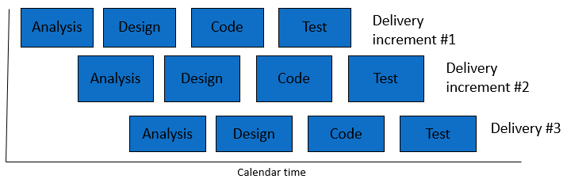
Incremental Development
- Provide an analysis regarding the nature and environment of the software that you are going to develop and select the best suitable method(s) to develop the software.
- Present your arguments based on your analysis about why your selected method(s) is the best choice among all other methods to develop your proposed software.
- Presents sufficient amount of evidence to support argument for your model selection in developing your proposed solution.

Project Role Identification and Responsibilities
Project Manager: The Project Manager provides coordination and oversight for iterative cycles of planning, development, and review. They ensure that resources, schedules, and scope are iteratively adjusted to accommodate evolving stakeholder input and requirements. The Project Manager primarily focuses on overseeing the incremental delivery of functional components while keeping in step with the project's big-picture objectives.
Business Analyst: The Business Analyst continuously elaborates on the project's requirements through close collaboration with stakeholders. The priorities of features in each iteration are determined based on client feedback and changing requirements. The Business Analyst ensures that the team stays aligned with the project's goals and that any changed requirements are properly documented throughout the process.
System Architect/Designer: The System Architect/Designer creates a system architecture to support iterative development. They design modular, scalable components that can be incrementally improved. At the end of each cycle, the designs and interfaces are updated to reflect findings and feedback, ensuring the system remains responsive to emerging requirements.
Development Team: The Development Team is responsible for delivering functional components through small iterative cycles. They develop features, integrate feedback from clients and testers into the code, and ensure it remains maintainable and adaptable for future increments. Their work focuses on achieving high-quality outcomes after each incremental delivery.
Test Team and Quality Assurance: After every iteration, the Test Team performs rigorous testing to ensure the functionality works as expected and identifies any bugs. They provide valuable feedback to the Development Team for defect resolution and ensure each incremental delivery meets the specified requirements. Their iterative testing ensures consistent quality and functionality improvement of the product.
Documentation Team: This team develops and updates project-related documentation throughout the system's lifecycle, including technical documents, user manuals, and specifications. Following each iteration, they document changes and enhancements to ensure the evolving system is well-documented and accessible.
Customer/Client: The Client is actively engaged in reviewing iterative deliverables to support continuous improvement. They approve incremental deliveries, provide insights for refinement, and collaborate with the project team to reassess priorities as the project unfolds.
Safety and Compliance Experts: These professionals continuously review the project to ensure every aspect of the process complies with safety and legal standards. As new features or components are developed, they update safety protocols and compliance measures to ensure adherence to the latest standards throughout the iterative process. All roles emphasize key aspects such as flexibility, continuous feedback, and incremental improvement. This approach allows better adaptation to changing needs while ensuring collaboration and regulatory compliance.
Existing emergency service solutions in Bangladesh rely on manual, call-based systems with limited capacity, lacking real-time tracking, predictive analytics, and integration across services, leading to delays in response. Our proposed solution introduces an AI-powered unified platform with real-time GPS tracking, predictive analytics, and a user-friendly interface, ensuring faster responses, better resource management, and improved accessibility, addressing current gaps effectively.

The development of an emergency service system as described addresses significant societal, health, safety, legal, and cultural issues, enhancing public well-being and trust. Here is a detailed analysis of these impacts:
Societal Impact: The proposed system bridges critical gaps in emergency response infrastructure. By enabling real-time tracking, quick access to services, and AI-based decision-making, it improves community resilience to crises. Efficient emergency handling fosters public confidence, minimizes response disparities in urban and rural areas, and reduces societal disruptions during emergencies.
Health Impact: Faster access to healthcare services, including ambulances and virtual consultations, can significantly lower mortality and morbidity rates. The system’s streamlined response mechanism ensures immediate medical attention, thereby addressing life-threatening conditions more effectively and reducing the burden on healthcare systems.
Safety Enhancements: Incorporating precise location tracking and reducing response times greatly enhances personal and public safety. Automated alert systems prevent human error, and penalties for false reports deter misuse, ensuring that resources remain available for genuine emergencies.
Legal Considerations: The system must comply with data privacy and cybersecurity regulations, given access to personal data and real-time location information. Secure login protocols, user verification, and proper data management ensure adherence to local laws while protecting user rights. False request penalties also align with legal frameworks designed to prevent service misuse.
Cultural Sensitivity: Emergency services are critical across diverse cultural contexts. Customizable service preferences, language support, and region-specific emergency categorization promote inclusivity and accessibility, ensuring equitable service delivery. Tailoring services to cultural nuances helps build trust and ensures widespread adoption.

Overall, this integrated approach strengthens emergency management, aligns with legal standards, enhances public health and safety, and respects cultural diversity, making it a comprehensive solution to modern emergency response challenges.

Activity:
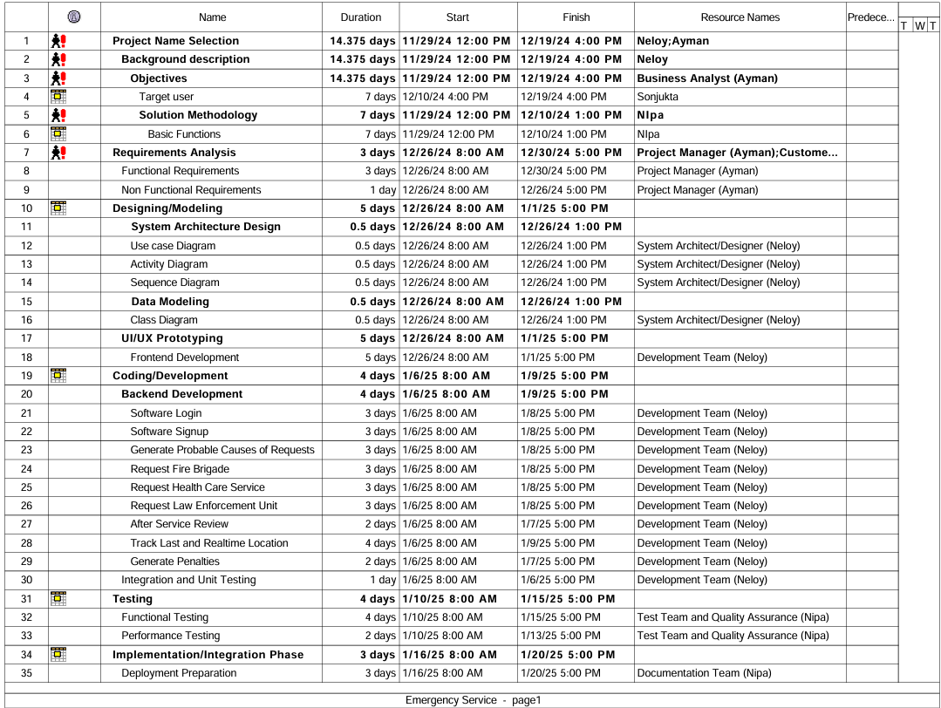
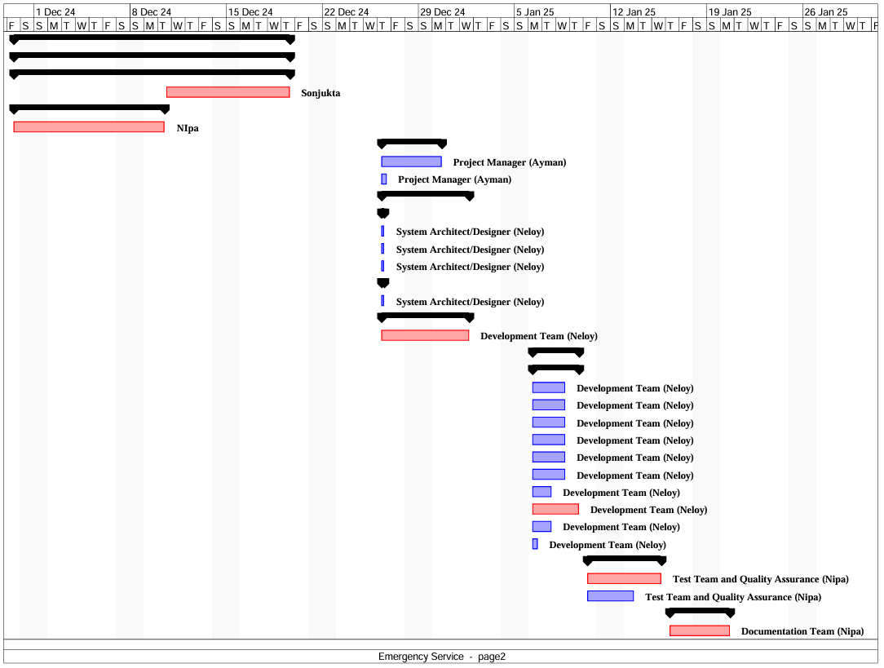

Resources :
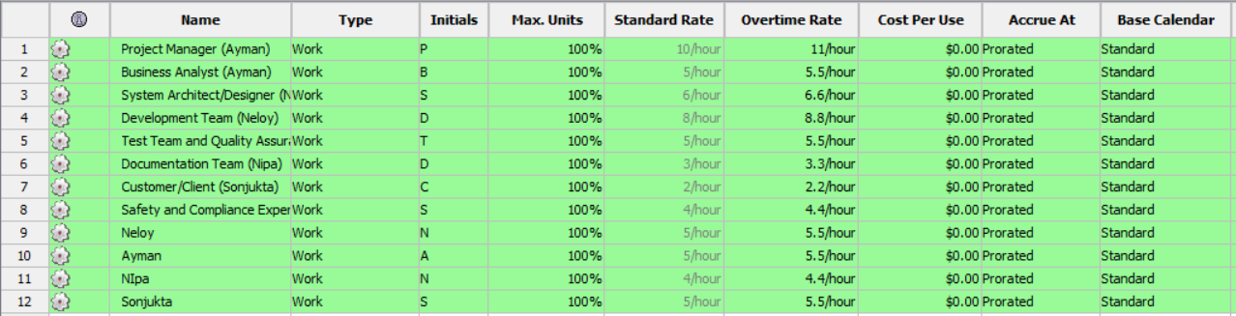

Risk:

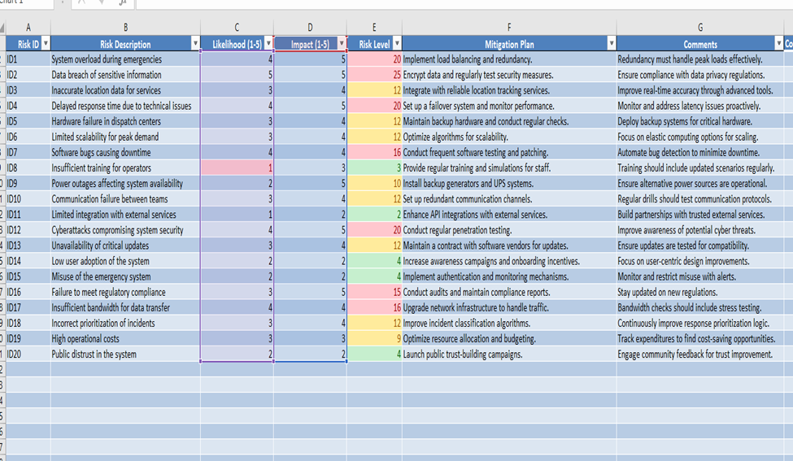

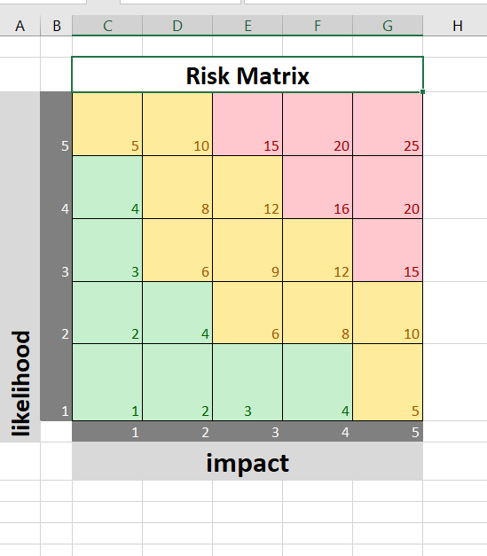

Rubric for Project Assessment (CO3)
Criteria | Marks distribution (Max 3X5= 15) |  |  |  | Acquired  Marks
Criteria | Inadequate (1-2) | Satisfactory (3) | Good (4) | Excellent (5) | Acquired  Marks
Selection of Software Engineering Models | Does not articulate a position or argument of choosing appropriate model. Does not present any evidence to support the arguments for the choice of the model | Articulates a position or argument for choosing models that is unfocused or ambiguous. Presents incomplete/vague evidence to support argument for model choice | Articulates a position or argument of choosing models that is limited in scope. Does not present enough evidence to support the argument for the choice of the model | Clearly articulates a position or argument for the choosing software engineering models. Presents sufficient amount of evidence to support argument for the model selection
Role identification and Responsibility Allocation | The project has poor project management plans for identifying roles and assigning the responsibilities | Identify few roles in the project management where some of the roles are left alone with any project responsibilities | Identify most of the roles in the project management and assign their responsibilities | Well planned project with proper role identification and responsibility allocation in the project management activities
Impact identification
Formatting and Submission | Project report is not complete and Several errors in spelling and grammar. Present a Confusing organization of concepts, supporting  arguments, and  real-life example.  Sentences rambling, and details are repeated. | Some errors in spelling and grammar. Some problems  of organizing the answer in a logical order of defining,  elaborating, and providing real-life examples. | Few errors in spelling and grammar. Presents most of the details in a logical flow of  organization in  definition,  details, and  example. | Project report is complete and No errors in spelling and grammar. Consistently  presents a logical  and effective  organization of definition,  details, and real-life example of  the topic.
Acquired marks:
CO Pass / Fail:

Rubric for Project Assessment (CO4)
Marking Criteria | Marks Distribution (Maximum 3X5=15) |  |  |  | Acquired Marks
Marking Criteria | Inadequate (1-2) | Satisfactory (3) | Good (4) | Excellent (5) | Acquired Marks
Project Planning | No background information regarding the project is  given; project goals and benefits are  missing. | Insufficient background information is given; project goals and benefits are  poorly stated | Sufficient background information is given; the purpose and goals of the project are explained. | Thorough and relevant background information  is given; project goals are clear and easy to identify.
Effort Estimation and Scheduling | Student vaguely discuss the impact of societal, health, safety, legal and cultural issues in their project | Student provided with partial relevance to the impact of societal, health, safety, legal and cultural issues in their project | Student fairly provided the analysis to the impact of societal, health, safety, legal and cultural issues in their project | Student comprehensively provided the analysis to the impact of societal, health, safety, legal and cultural issues in their project
Risk Management | Ambiguous representative example. | Partially identify / indicate towards real-life example. | Real-life example is fairly connected towards the definition. | Comprehensively defend with real life example.
Acquired Marks:
CO Pass / Fail:

CO5 [PO-i-2]: Perform as an effective team member or leader in diverse team settings and solve multi-disciplinary problems in computer science and engineering domain.
Assessment  Attribute/Criteria | Missing/ Incorrect (0) | Inadequate  (1) | Satisfactory  (2) | Excellent  (3)
Taking  responsibility | Does not perform assigned tasks; often misses meetings and, when present, does not have anything constructive to say; relies on others to do the work; | Partially performs all assigned tasks; attends meetings irregularly and occasionally participates and hence not reliable; | Performs all assigned tasks; attends meetings regularly and usually participates effectively.  generally reliable; | Performs all tasks very effectively; attends all meetings and participates enthusiastically; very reliable.
Contributions | Never provides useful ideas when participating in a group discussion | Rarely provides useful ideas when participating in a group discussion | Sometimes provides useful ideas when participating in a group discussion | Routinely provides useful ideas when participating in a group discussion
Collaboration and Ability to Compromise | Not cooperative, unable to compromise and disrupts the team process. | Sometimes cooperative, and rarely displays a positive attitude. | Usually cooperative, able to compromise and generally display positive attitude. | Always cooperative. Willingness to compromise. Always display positive attitude.
Valuing other  team members (Working with others) | Often argues with teammates; doesn't let anyone else talk; occasional personal attacks and "put‐downs"; wants to have things done his way and does not listen to alternate approaches. | Seldom listens to others' points of view; occasionally behaves in an oppressive manner; tries to force their own ideologies on other. | Generally, listens to others' points of view; always uses appropriate and respectful language; tries to make a definite effort to understand others' ideas. | Always listens to others and their ideas; helps them develop their ideas while giving them full credit; always helps the team reach a fair  decision.

